* **Activity 6:**

Using General Functions

1. **Calculate annual compensation:**

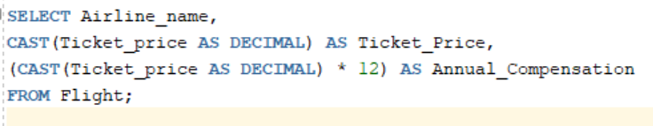

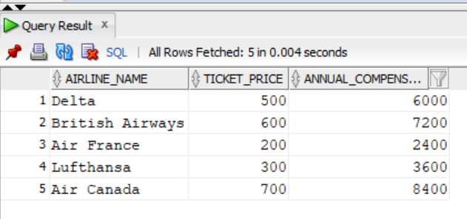Output:

1. **Use NVL2 function to examine ticket prices:**

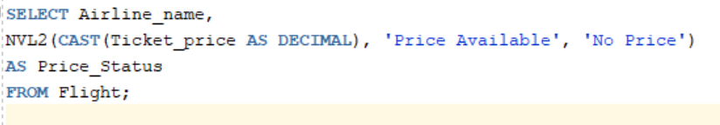

Output:

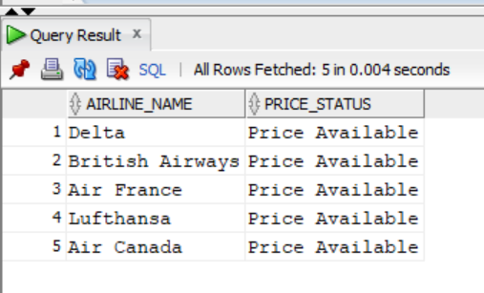

1. **Use NULLIF to compare lengths of different columns:**

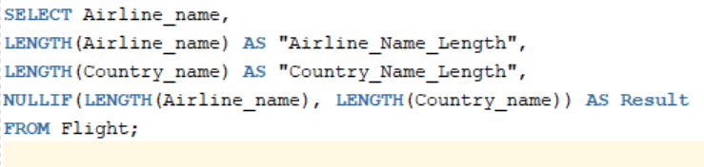

Output:

